**0Installation of Anaconda**

1. Download Anaconda3 2020.07 for windows

<https://www.anaconda.com/download/#download>

1. Click on the .exe file downloaded for installation.
2. Now in startup search, 'jupyter notebook'

You will see a web interface popping up.

You may choose to open in google chrome.

## How To Use Jupyter Notebooks

Type *'jupyter notebook'* in terminal

Then you'll see the application opening in the web browser on the following address: http://localhost:8890(localhost port no may vary). This all is demonstrated in the gif below:

F,{24a79f4a-6c8e-4f78-9198-dc0ca68c2ce7}{46},3.125,3.125

The "Files" tab is where all your files are kept, the "Running" tab keeps track of all your processes and the third tab, "Clusters", is provided by IPython parallel, IPython's parallel computing framework. It allows you to control many individual engines, which are an extended version of the IPython kernel.

You probably want to start by making a new notebook.

You can easily do this by clicking on the "New button" in the "Files tab". You see that you have the option to make a regular text file, a folder, and a terminal. Lastly, you will also see the option to make a Python 3 notebook.

Let's start first with the regular text file. When it open up, you see that this looks like any other text editor. You can toggle the line numbers or/and the header, you can indicate the programming language you're writing and you can do a find and replace. Furthermore, you can save, rename or download the file or make a new file.

You can also make folders to keep all your documents organized together. Just press the "Folder" option that appears when you press the "New" button in your initial menu and a new folder will appear in your overview. You can best rename the folder instantly, as it will appear as a folder with name 'Untitled Folder'.

Thirdly, the terminal is there to support browser-based interactive terminal sessions. It basically works just like your terminal or cmd application! Give in python into the terminal, press ENTER, and you're good to go.

Tip: if you would ever need a pure IPython terminal, you can just type 'ipython' in your Terminal or Cmd. This can come in handy when, for example, you want to get more clear error messages than the ones that appear in the terminal when you're running the notebook application.

If you want to start on your notebook, go back to the main menu and click the "Python 3" option in the "Notebook" category.

You will immediately see the notebook name, a menu bar, a toolbar and an empty code cell:

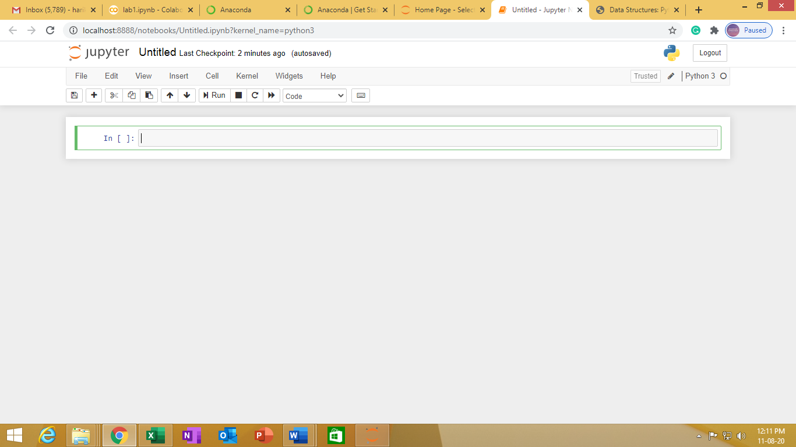

Those who want to start with python programming and the various data structures available, you may follow the link Data Structures in python at

<https://www.datacamp.com/community/tutorials/data-structures-python>

<https://machinelearningmastery.com/load-machine-learning-data-scratch-python/>